**Sending of Results from EVO3 to External File**

The results of the commands can be saved in the ini file “*cfg.ini*” that was set in the check program for retrieval purposes.

**Code-Related Commands**

By default, the check program “*Code_Reader.ckp*” is used to run EVO code-related command tools.

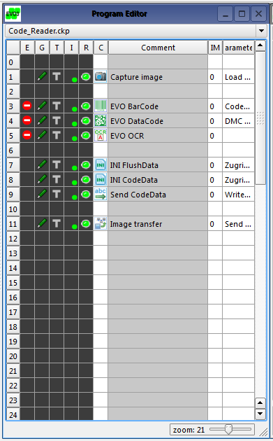

Due to some issues with using a single “*Ini access*” command to properly write the values of the code results into the file “*cfg.ini*”, the following commands/steps have been taken instead:

1. INI FlushData – Use an “*Ini access*” command to delete the section, known as “*camcode1*”, which consists of the previous code result. This is to ensure that the section with the code result is constantly flushed so that old code results will not accumulate and new code results can be written into the correct location.

There are 2 reasons for using the “Delete section” access type instead of the “Delete file” and “Delete entry” access types.

Firstly, only a single file was used to store the results and settings for all the command tools so it is not possible to delete the file just to flush the code result.

Secondly, the “Delete entry” access type has some issues with deleting the previous code result properly as it will only delete the entry name but not the previous code result. Therefore, at the point of the web-based GUI development, the best way is to use the “Delete section” access type to flush the previous code result.

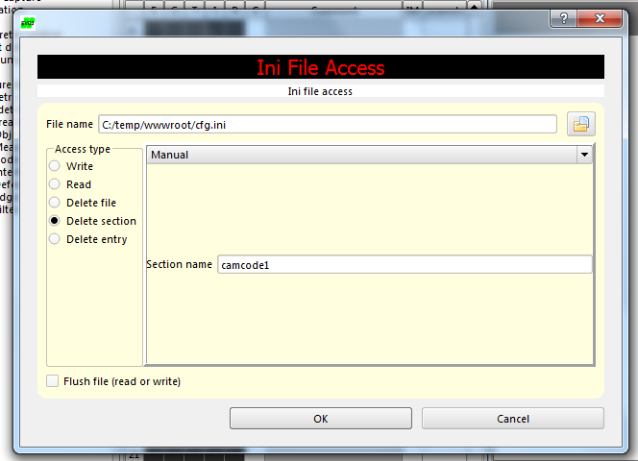

1. INI CodeData – Use another “*Ini access*” command to create the section “*camcode1*” and the entry “*coderesult1*” in the ini file “*cfg.ini*” for the code result can be written into. The “*Write data type*” needs to be set as “*Text*” with an empty manual string.

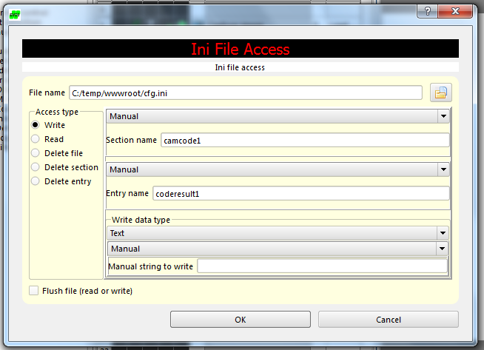

1. Send CodeData – Use “*Text string*” command to write the code result into the previously created section and entry in the ini file “*cfg.ini*”.

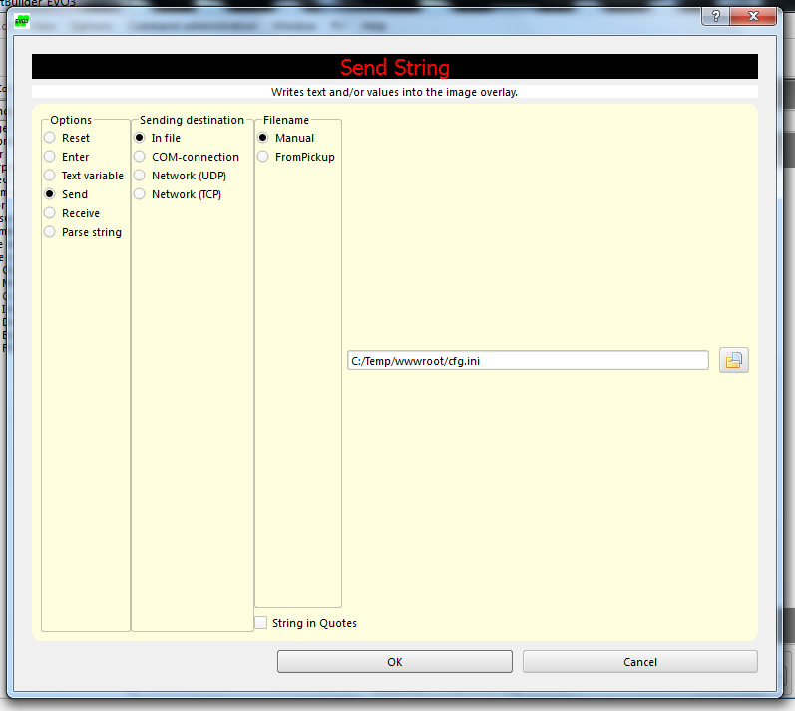

**Measurement-Related Commands**

By default, the check program “*Measurement.ckp*” is used to run EVO measurement-related command tools.

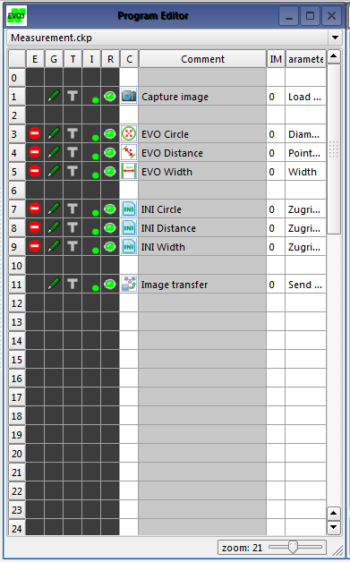

To save the results in the ini file “*cfg.ini*”, the “*Ini access*” command was used for each measurement command tool to create the section “*cam1*” and the entry “*result1*” in the ini file “*cfg.ini*” for the code result can be written into. It is also required to set the “*Write data type*” as “*Value*” and the pickup-list selection to be set to the position of the measurement command tool.

For example, if it is required to save the results of the “*EVO Circle*” command tool as seen in the check program “*Measurement.ckp*”, the settings of the “*Ini access*” command will be as follow:

